Lab PM - Projectile motion

Equipment

- Projectile launcher, with air pump
- Two clamps
- Steel ball
- Board and two lab jacks
- Roll of wax marking paper
- Projectile stop
- Bubble level
- 2-m ruler or tape measure
- 30-cm ruler
- Triangle
- Cylindrical container with weight inside (200 g approx.)

Background
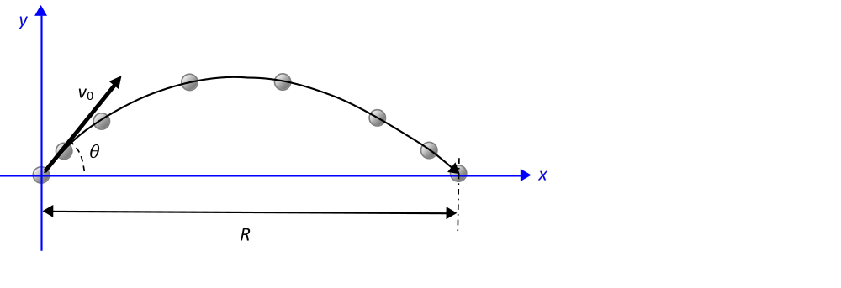
The projectile in the figure to the right is launched and lands at the same level, which we can take as y = 0.
Therefore, we can write:
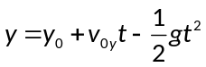
Solving for t, we obtain the time the projectile spends in the air:
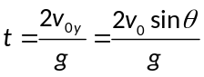
Using this time, we can then determine the distance traveled in the horizontal direction or range R:
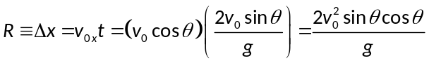
Since 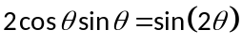, we can rewrite the last expression as:
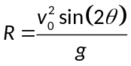 [Eqn. 1]
Prediction: Based on Equation 1, how do you expect the range to increase/decrease between the angles of 0 and 90°?

I think the range will increase as the angle increases from 0 degree to 45 degrees and decrease from 45 degrees to 90 degrees.

Experimental Setup

We will use a projectile launcher to verify the relationship between range and angle obtained above, and we will use the collected data to determine the initial speed of the projectile.

The Vernier projectile launcher uses compressed air to shoot projectiles with adjustable initial angle and speed.
Warnings
Do not load a projectile into the launcher until instructed to do so.
Do not overtighten the adjustment knobs or connectors.
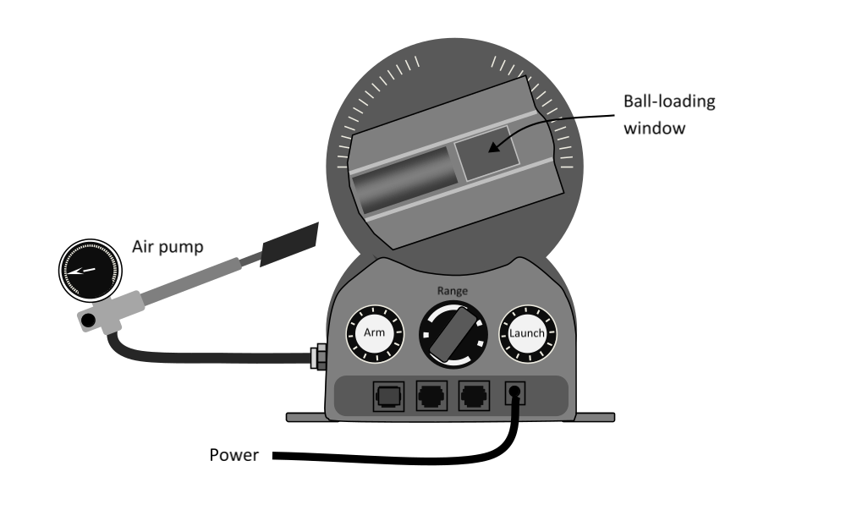

Pressure adjustment
The initial speed of the projectile can be adjusted with the Range knob. This knob controls the air pressure.

Check the launcher’s connections to the pump.

To pump air into the launching chamber:
- Pump until you clearly hear the sound of air leaking out.
- Continue pumping until you hear that sound 3 times.
- Wait a few seconds. You should see the pressure stabilize.

Check if a ball has been loaded into the chamber. If there is one, make sure you have a clear path for the launch before the next step!

To release the air, press Arm and, while holding it, press Launch simultaneously. Check that this works. You should hear the air release.

The initial speed of the projectile will depend on the pressure in the launching chamber. You can adjust this with the Range knob. Turning it clockwise/counterclockwise will increase/decrease the pressure and thus the initial speed.

For today’s experiment, the working pressure should be set around 35-40 psi.

Leveling of the launcher

We need to make sure that the 0° angle in the launcher really corresponds to the horizontal.

The leveling procedure has two steps:

- Level the launcher: Loosen the launcher with the lowest screw on the back of the dial. Place the bubble level on top of the launcher. Gently tighten the screw again when the launcher is in the horizontal direction.

- Level the dial: Loosen the dial with the highest screw on the back of the dial. Rotate the dial as needed until the notch marking the axis of the launcher is aligned with the 0° mark. Gently tighten the screw again. This screw should not be touched again today. If you accidentally do, repeat the whole leveling procedure.

For this experiment, we want to work with projectiles whose launching and landing points are at the same level. The setup is shown below.
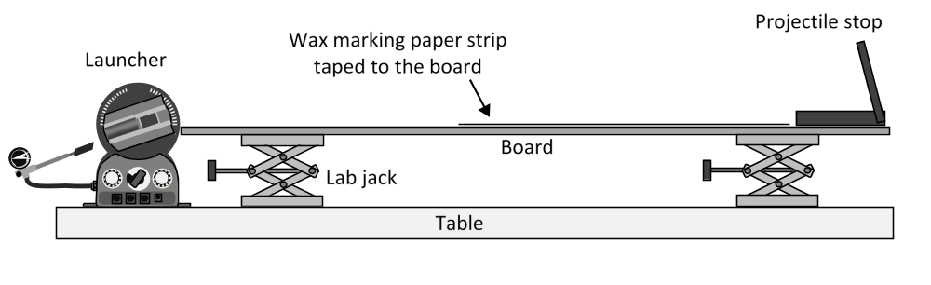

Board setup procedure

- Place the board on the jacks. The board should be more or less horizontal and aligned with the launching point (the center of the dial), but do not bother with precise adjustments yet.

- Before placing the marking paper on the board, do a few of test shots at around 45°. The ball should bounce near the end of the board, close to the projectile stop and be caught by it. If needed, increase or decrease the working pressure with the Range knob.

- Provisionally adjust the jacks to the top surface of the board about 2 cm above the 0° mark on the launcher’s dial. Press the meter stick flat against the back of the launcher (if the screw is in the way, adjust the height of the board as needed). The projectile will travel parallel to this direction.

- Cut a 60 cm strip of wax marking paper. Starting right next to the Projectile stop, place it parallel to the meter stick, white side up. The projectiles should always land on this strip. Tape it in place. No marking paper is needed in the area closer to the launcher because no projectile should fall in this area for the initial speeds and angles we will be working with.

- Check that the launcher is securely clamped to the table. It is essential that the launcher does not move during this activity.

- Precise alignment and leveling of the board:

- We want the ball to start and end at the same level. The center of the ball will start its motion at the 0° mark in the launcher. At the end of the motion, the bottom of the ball will touch the board and leave a mark. Therefore, we need to adjust the jacks so the top surface the board is one ball radius (8.8 mm) below the 0° mark. (Use the triangle for fine adjustments and just do your best to estimate these 8.8 mm on a ruler).
- With the bubble level, adjust the stop end of the board so the board is horizontal. Note that the lab tables are not necessarily perfectly horizontal.
- Recheck the alignment of the launcher end. If needed, repeat steps a and b.
- There should be no space between the dial and the board.

Data collection
Do not touch the Range knob during the entire experiment. If you change the launch pressure and therefore the initial speed, you need to restart the measurements.
Launch the projectile for at least 10 different angles between 20° and 70°. The initial speed of the projectile varies between 0.5% and 1% depending on the launcher. To improve precision, repeat the launch at least 3 times for each angle.
Tips and technical details:
- It is best to leave all the measurement of distances with the ruler for the end. Do all the launches required for the experiment first. Use a pencil to label the marks as they are produced:
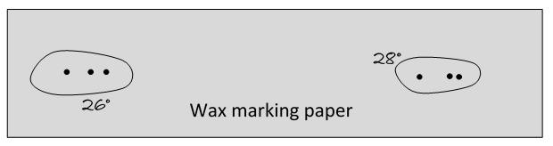
Once all the impacts have been recorded, you can move the board (without un-taping the marking paper!) and comfortably place the ruler.
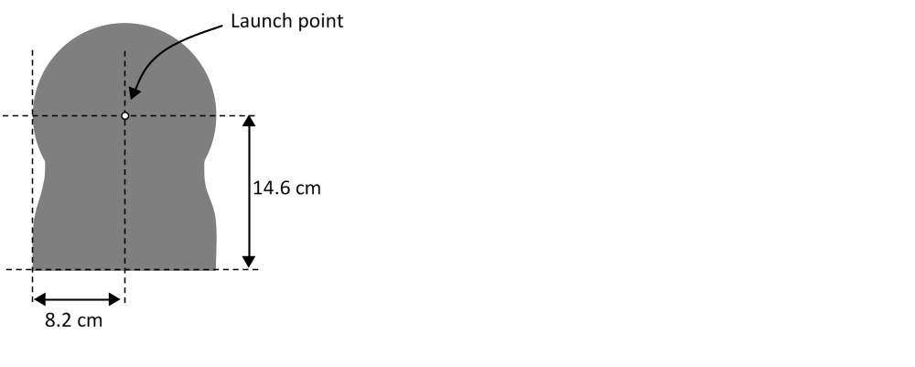
- The projectile is shot from the center of dial. The dimensions of the launcher are inscribed in the back of the launcher and in the figure to the right. Do not forget to take this into account in your distance measurements!

- Clean the projectile with a tissue paper every few shots. The projectiles slowly pick up wax from the tape and they will get stuck in the barrel if the wax is not removed.

Collect all your data (angle and range for each launch) on a table. Remember to include labels and units! Insert the table below.

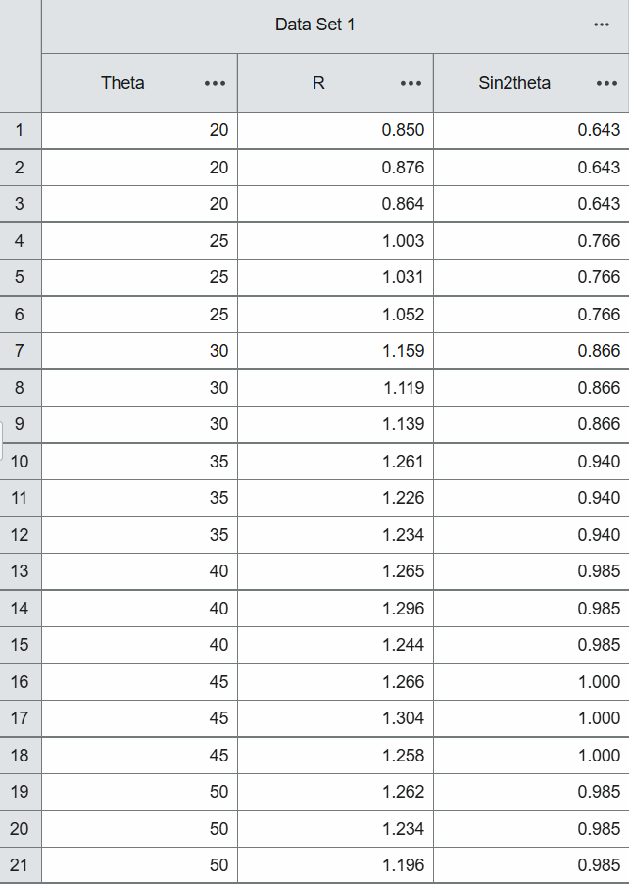
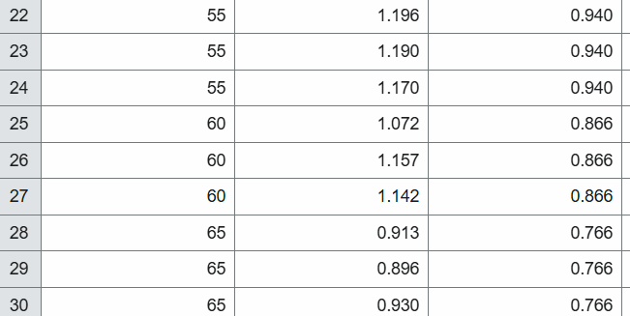

Data analysis
Plot the range as a function of the angle. Insert the plot below.

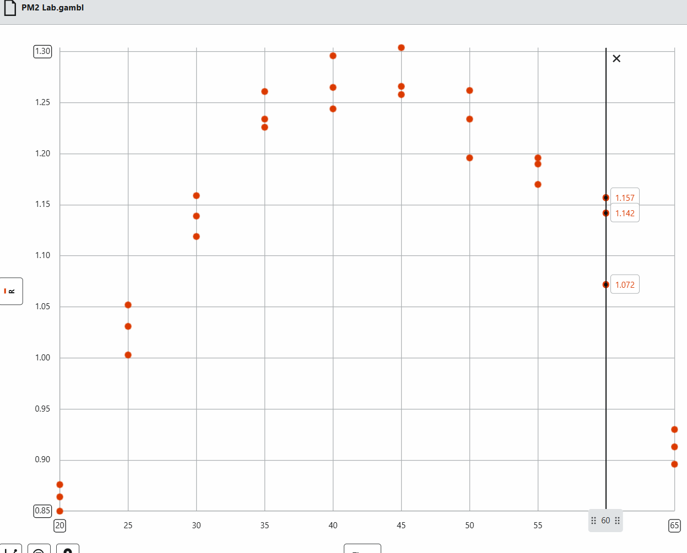

According to equation 1, the range R should be proportional to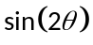. Insert a new column in the table for and produce a new plot: R vs.. If everything went right, this plot should be linear. If that is the case, add a linear fit.
If the plot is not linear, you need to figure out what happened.
Insert below the table with the extra column and the new plot.

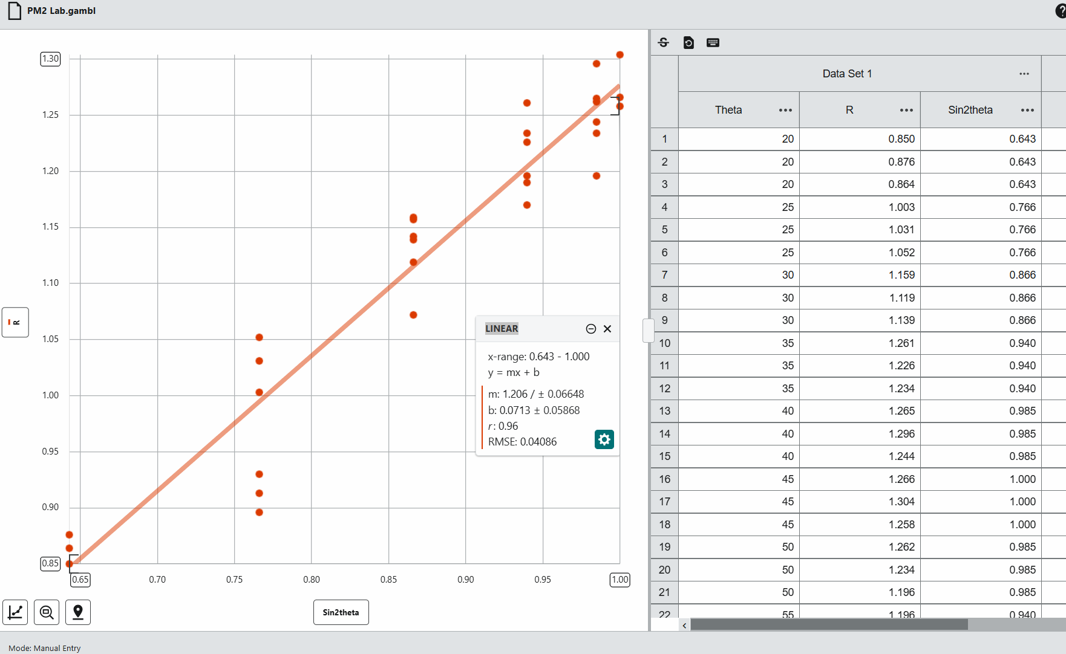

Use the linear fit to determine the initial velocity of the launcher. Show all your calculations.

Slope= 1.206
∆m=0.06648
$V_{0}=\sqrt{1.206*9.8}=3.438$m/s
$∆v=\frac{1}{2}v_{0}*\frac{∆m}{m}=0.5\left(3.438\right)\left(\frac{0.06648}{1.206}\right)=0.095$m/s
$$V_{0}=3.437±0.095\frac{m}{s}$$

Conclusions
Did the range depend on the angle as predicted? Explain. Your reasoning must be explicitly based on the data.
Yes the range did depend on the angle as we predicted. As our angle incresed from 20 to 45 the range increased. But as our angle increased from 45 to 65 the range decreased. At the angle of 45 degrees the range of the ball was the largest.

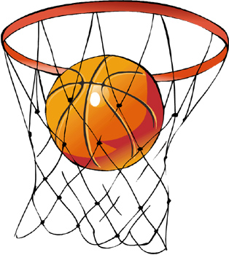
Application: Free throw!
Now that you have an estimation of the initial speed of the ball, we challenge you to get the ball in a cylindrical container placed about one meter from the launcher… in one shot.
If you want to reuse equation 1, consider carefully the geometry of your setup. (Hint: This is about the position of the top of the container). Alternatively, you can derive the equation for a different setup.
To prevent the container from tipping over, a 200-g weight should be placed at the bottom.
Show all your measurements and calculations below.

$$R=\frac{{v_{0}}^{2}sin⁡(2Θ)}{g}$$
$$\frac{1}{2}\sin^{-1}\left(\frac{1*9.8}{{(3.438)}^{2}}\right)=28 degrees$$

When done, set up the launcher according to your results and… take a shot! Did it go in? If not, discuss with your partner and/or your instructor what went wrong. If you can figure it out, you get a second shot!

Yes, it went in with an angle of 28 degrees

In the context of projectile motion, range is the total horizontal distance covered by the projectile, which of course increases with initial speed.

